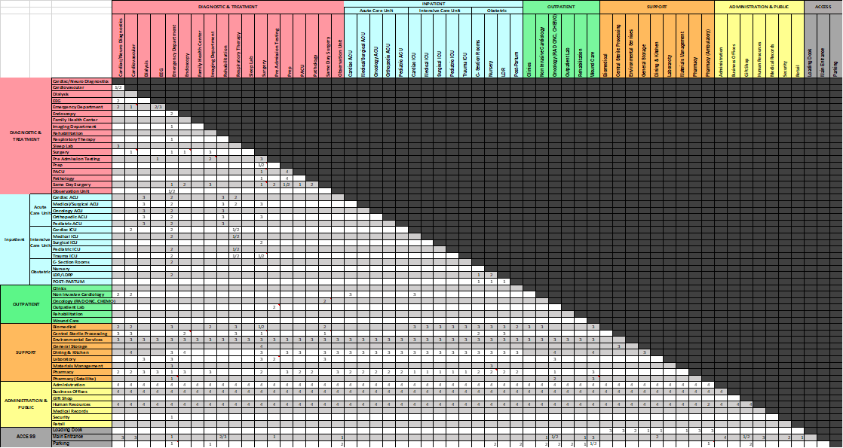
ZhouZhou Su 2015-2016: Optimizing Spatial Adjacency in Master Planning
This study develops an automated computational tool to assist architects and planners in the master planning stage of a healthcare project. It proposes a rating system for evaluating existing hospital plans as well as proposed designs, and seeks optimal design solutions automatically, based on a series of algorithms which incorporate spatial adjacency requirements and travel distances between key departments.

